3E Team Points
PARKS  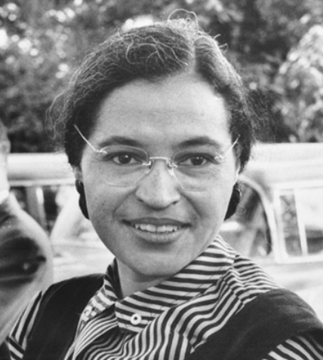  Dylan  Zayn  Subhan  Husna  Skylar-Jai  Ellie  Mia  Luca | HAWKING  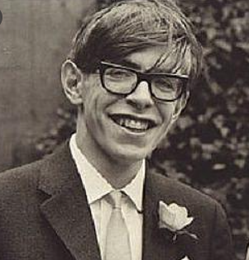  Theo  Elliot  Ella Grace  Imaan  Autumn  Anandjot  Arshdeep  Qasim
MANDELA  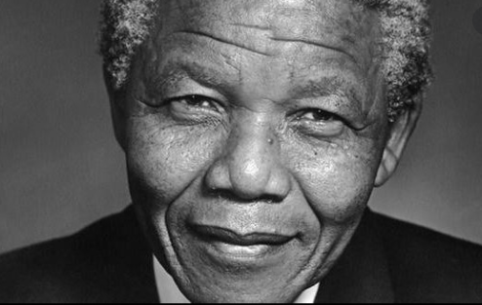  Maddie  Ibrahim  Isla  Moosa  Yahya  Erin  Hamza  Alfred | PANKHURST  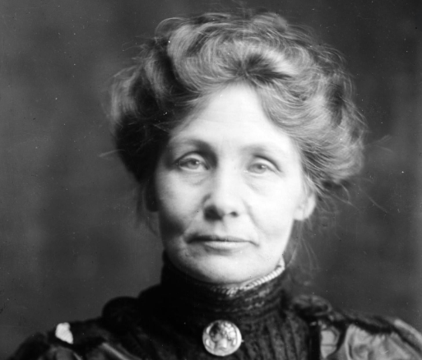  Tilly  Amber  Lilli  George  Nathan  Addison  Zayne  Mekhi

